**What do white birds and Mount Rushmore have in common?**

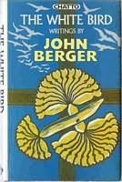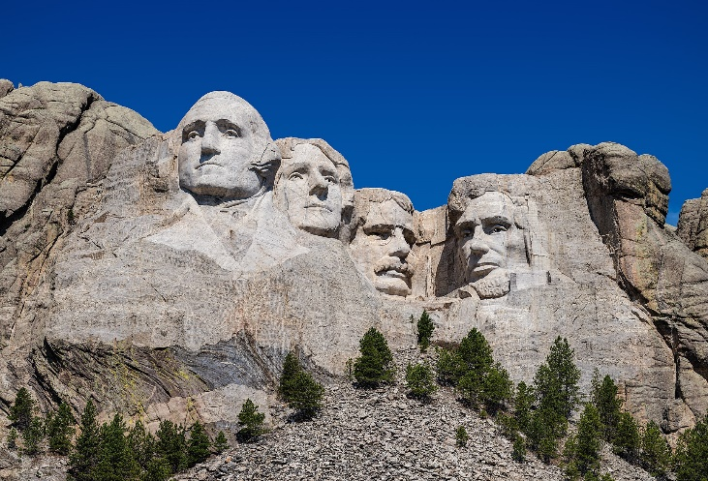

**Introduction and Lesson Overview**

Art of all kinds influences perception and understanding of human experience, and it is an art critic’s task to analyze, interpret, and evaluate works of art of their significance. In this lesson, you will read and analyze an excerpt of “The White Bird,” an essay written by art critic John Berger (1926 – 2017). Berger uses the example of carved, white wooden birds as a form of artwork to draw conclusions about how the qualities of artwork contribute to its ability to influence a viewer. These qualities can be applied to understanding other forms of artwork, not just the white birds about which Berger writes.

Read the passage below. Once you have finished reading, respond to the questions and writing prompts in Part 1, which are designed to aid you in your thinking about art and its qualities. When you have finished Part 1, you will be ready to move on to applying what you have just learned to an analysis of Mount Rushmore National Memorial in Part 2!

**Excerpt from “The White Bird,” by John Berger (1985)**

“It would be absurd to compare one of these wooden birds to a van Gogh self-portrait or a Rembrandt crucifixion. They are simple, home-made objects […] yet by their very simplicity, they allow one to categorize the qualities which make them pleasing and mysterious to everyone who sees them.

First there is a figurative representation **–** one is looking at a bird, more precisely a dove, apparently hanging in mid-air. Thus, there is a reference to the surrounding world of nature. Secondly, the choice of subject (a flying bird) and the context in which it is placed (indoors where live birds are unlikely) render the object symbolic. This primary symbolism then joins a more general, cultural one. Birds, and doves in particular, have been credited with symbolic meanings in a very wide variety of cultures.

Thirdly, there is a respect for the material used. The wood has been fashioned according to its own qualities of lightness, pliability, and texture. Looking at it, one is surprised by how well wood becomes bird. Fourthly, there is a formal unity and economy.Despite the object’s apparent complexity, the grammar of its making is simple, even austere. Its richness is the result of repetitions which are also variations. Fifthly, this man-made object provokes a kind of astonishment: how on earth was it made? […]

These five qualities, when undifferentiated and perceived as a whole, provoke at least a momentary sense of being before a mystery. One is looking at a piece of wood that has become a bird. One is looking at a bird that is somehow more than a bird. One is looking at something that has been worked with a mysterious skill and a kind of love.”

**Part 1: Responses to “The White Bird” Excerpt**

Reflect on what you have read and respond to the following questions and prompts. These questions and prompts are designed to help you think through and define the qualities of art as discussed in the excerpt. Answering them will help you analyze Mount Rushmore National Memorial in Part 2 of this activity.

1. **What was challenging about reading this excerpt? Identify a challenge you faced and offer an explanation.**
2. **Identify a key ‘takeaway point’ you feel was especially important to you when you read this piece.**
3. **Define the terms below in your own words.** You may wish to re-read the passage and reflect on the contexts in which these terms appear.

***Figurative Representation***

***Subject***

***Context***

***Symbolic Meaning***

1. **Match the term to the specific example referenced in the text.** In other words, what examples does John Berger cite in his discussion of each of these art qualities?

***Figurative Representation***

***Subject***

***Context***

1. Berger writes that “Birds, and doves in particular, have been credited with symbolic meanings in a very wide variety of cultures.” Think about doves and their symbolism as they apply to your own culture(s). **What are some of the symbolic meanings you associate with doves?**

**Part 2: Interpreting Mount Rushmore as Artwork**

Berger’s white birds and Mount Rushmore National Memorial might not appear to be related, but they are both examples of artwork. In responding to art critic John Berger’s excerpt, you read about and reflected on artwork and its qualities. Now it is your turn to think like an art critic and apply what you have learned to an interpretation of Mount Rushmore National Memorial.

Use the excerpt, your responses in Part 1, and the National Park Service Mount Rushmore National Memorial website (<https://www.nps.gov/moru/index.htm>) to help you formulate your responses to the questions and prompts below. Specifically, the website has a section called “Learn About the Park” (<https://www.nps.gov/moru/learn/index.htm>) which offers resources to help you understand the history, people, and other contexts surrounding the production process of Mount Rushmore National Memorial. However, your own knowledge of art, of Mount Rushmore, and other personal experiences are also valuable resources to draw on in your responses, because to be an art critic means you are interpreting a work of art from a particular perspective and point of view.

1. One of the qualities of artwork which Berger discusses in the excerpt is figurative representation. Reflect on your earlier definition of figurative representation and apply this understanding to Mount Rushmore. **Identify the *figurative representations* of the Mount Rushmore National Memorial.**
2. Reflect on your own knowledge and experiences of Mount Rushmore National Memorial. **What symbolic themes comes to mind when you view the figurative representations of the sculpture?**
3. The sculptor of Mount Rushmore, Gutzon Borglum (1897 – 1941), had specific symbolic themes in mind when he selected the presidents to carve into the mountain at Mount Rushmore. **What are the symbolic themes for each of the four figures as Borglum envisioned them?**
4. George Washington
5. Thomas Jefferson
6. Abraham Lincoln
7. Theodore Roosevelt
8. Berger reflects on human-made art as objects which spark curiosity about how it is made. Art is created in part through the interplay of artistic medium and technique. An artistic medium (plural: media) consists of the combined tools and materials used by the artist to create artwork. Using tools and materials deliberately and with technique to produce a work of art is called technique. **Identify the material, tools, and selected techniques used in the creation of Mount Rushmore.**
9. Material matters when artists or caretakers of a work of art engage in processes of conservation and preservation, which are careful actions taken to maintain artwork. For example, John Berger’s wooden birds require conservation efforts to prevent rot from degrading the artwork. **What are some challenges to Mount Rushmore’s conservation and preservation that are associated with its specific medium? What actions does the National Park Service perform to preserve Mount Rushmore from the effects of these challenges?**
10. Berger’s excerpt ends with the following passage: “These five qualities, when undifferentiated and perceived as a whole, ***provoke at least a momentary sense of being before a mystery*** [emphasis added]***.*** One is looking at a piece of wood that has become a bird. One is looking at a bird that is somehow more than a bird. One is looking at something that has been worked with a mysterious skill and a kind of love.”

Reflect on your experience reading and responding to the excerpt, researching and analyzing Mount Rushmore as an art critic, and the passage above. Discuss whether you feel Mount Rushmore offers you a sense of being before a mystery, with supporting statements drawn from your responses above.